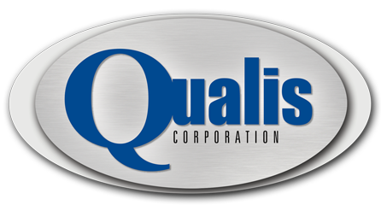

Employee Referral Policy

Employee Eligibility
- The Employee Referral Policy (ERP) is open to all regular full-time and part-time Qualis Corporation employees, with the exception employees in a Director Level position or above (Vice Presidents, Directors, Program Managers) and members of the Human Resources department.
- The referral award is applicable to all contract related positions.

Candidate Eligibility
- The referring employee must be listed on the employment application.
- Temporary, summer, consultants, former employees, previously interviewed candidates, or candidates that had previous employment discussions with Qualis Corporation are not eligible candidates for referral awards.
- Qualis Corporation reserves the right not to pursue a referred candidate if employment of said candidate would constitute a conflict of interest with a customer, supplier, and/or detrimental to the best interests of the Company.
- Only candidates who meet the essential qualifications for the position will be considered.
- All candidates will be evaluated for employment consistent with Qualis Corporations policies and procedures.
- All information regarding the hiring decision will remain strictly confidential.
Referral Award Eligibility
- The referral date cannot be earlier than the date the job requisition is posted.
- To be eligible for an award, the referral must submit a Candidate Referral Form (Form # REF-003-0912) to Human Resources.
- The employee must also have the candidate to apply for the position online at http://www.qualis-corp.com/careers.html, and the candidate must list the referrals name on the employment application.
- The first employee to refer a candidate will be the only referring employee eligible for payment.
- The hiring of a referred employee must occur within 180 days of the initial referral date.
- The referring employee must still be employed by Qualis during the hired candidate's first 180 days of employment in order to receive payment, and still be an active employee at the time of the award payout.
- Referring employees may not take part in the interview process. Such action would render them ineligible for award.

Award Eligibility and Payment
- Awards are paid in the amount of $1,000 (less applicable taxes and deductions).
- All referral bonus payments will be paid within 30 days after the referred employee's first 180 days of employment with Qualis.
- Human Resources will be responsible for reviewing the accuracy of eligibility, payment award for each position.
- Employee referral awards will not be approved retroactively.
- Any disputes or interpretations of the program will be handled through Human Resources.

